**A Report**

**On**

**VBE&A ASSIGNMENT-3**

**BODY PART MODELING AND VALIDATION**

SUBMITTED TO: -

**DR SUSHIL CHANDRA**

**Submitted By**

**Name of the Student**                                                      **Enrolment Number**

GUNDA VENKATA SAI JAI HARSHA                                190C2050003/190169



SCHOOL OF ENGINEERING AND TECHNOLOGY

BML MUNJAL UNIVERSITY GURGAON

**BODY PART:**

Back grip of Hero Maestro Edge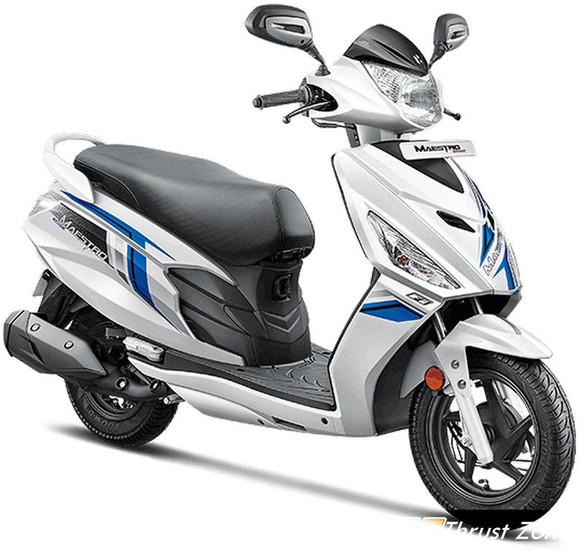

# ABSTRACT

In this project, I am making 3d modelling and 2d sketches of the back grip of Hero Mastero Edge and in this I will be making the fitment report of the back grip and then the gap analysis of the back grip with seat and gaps between them etc next I will be doing the clashing with the any part like seat at last I will be doing the function analysis of the back grip.

**Introduction**

In body part modelling I have taken back grip of Hero Mastero Edge scooty First I will be taking all the required measurements of the grip the sides and back and the gaps between the seat and grip, mountings etc and making note of them and then we will be starting with 2d sketch and make the 3d model.

The main use of the back grip is to keep the hands by pillion rider for grip and sit comfortly without falling and support the back to sit properly and make safe ride.

This is one Which I have taken all the measurements of Mastero edge Old model from Hero Lab.

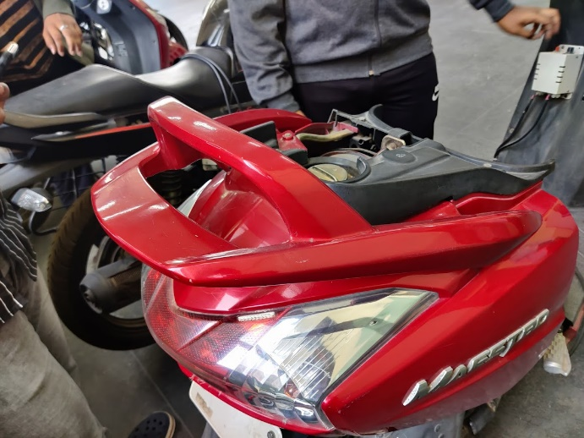

The is the new model of Mastero edge, We can see new updated back grip.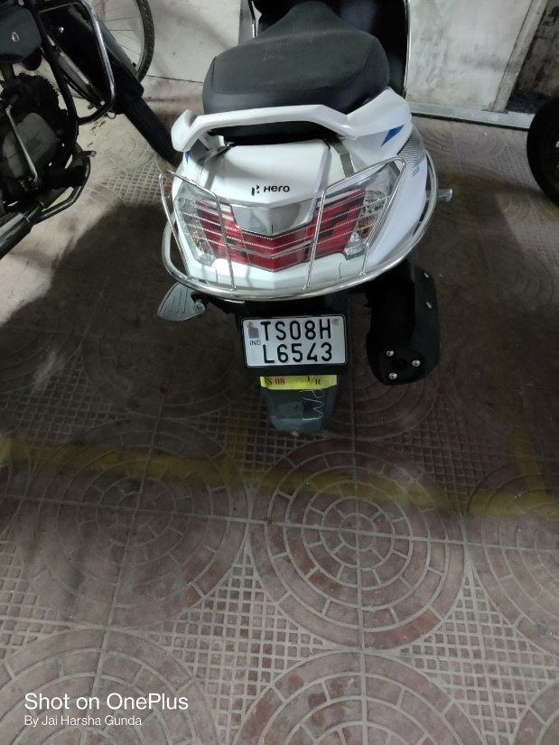

**3D MODEL**

This the back grip with angle as the scooty has with new model and with perfect dimensions.

Home View

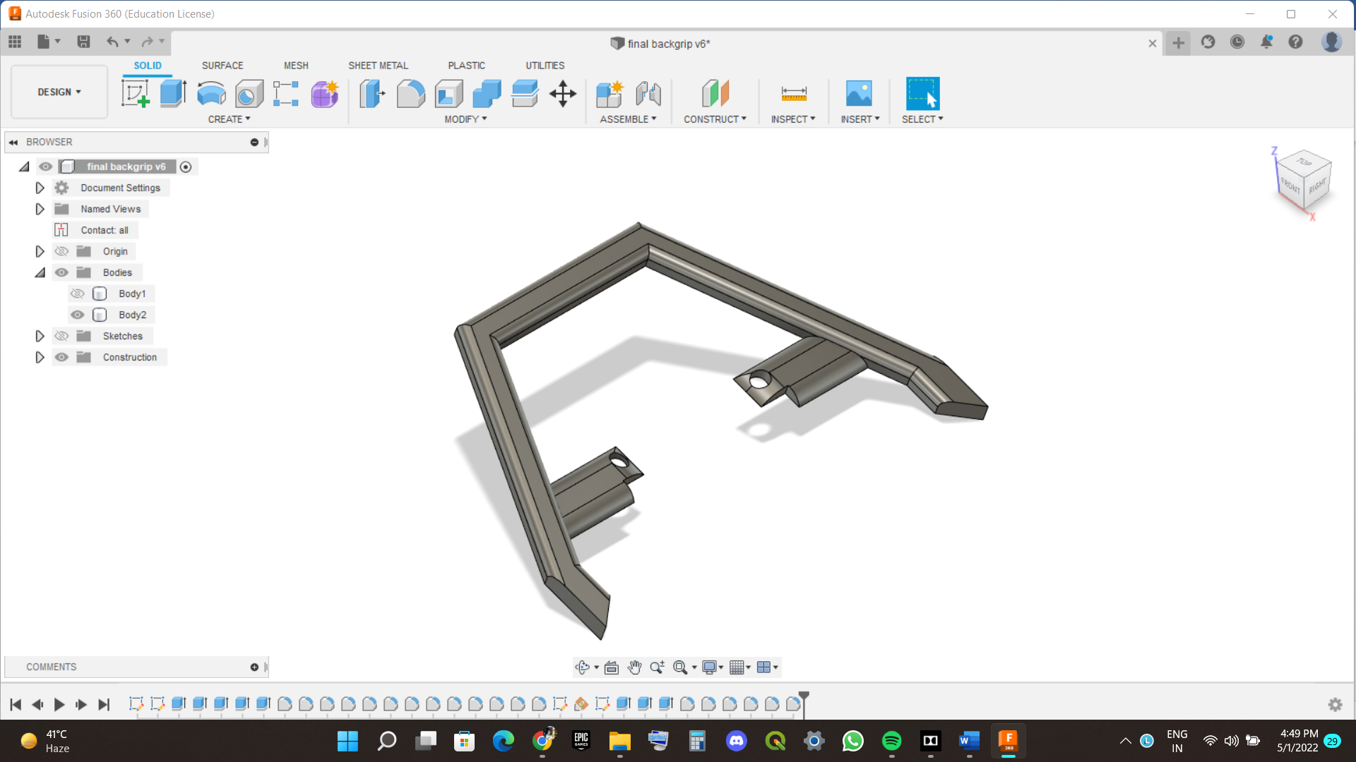

Top View

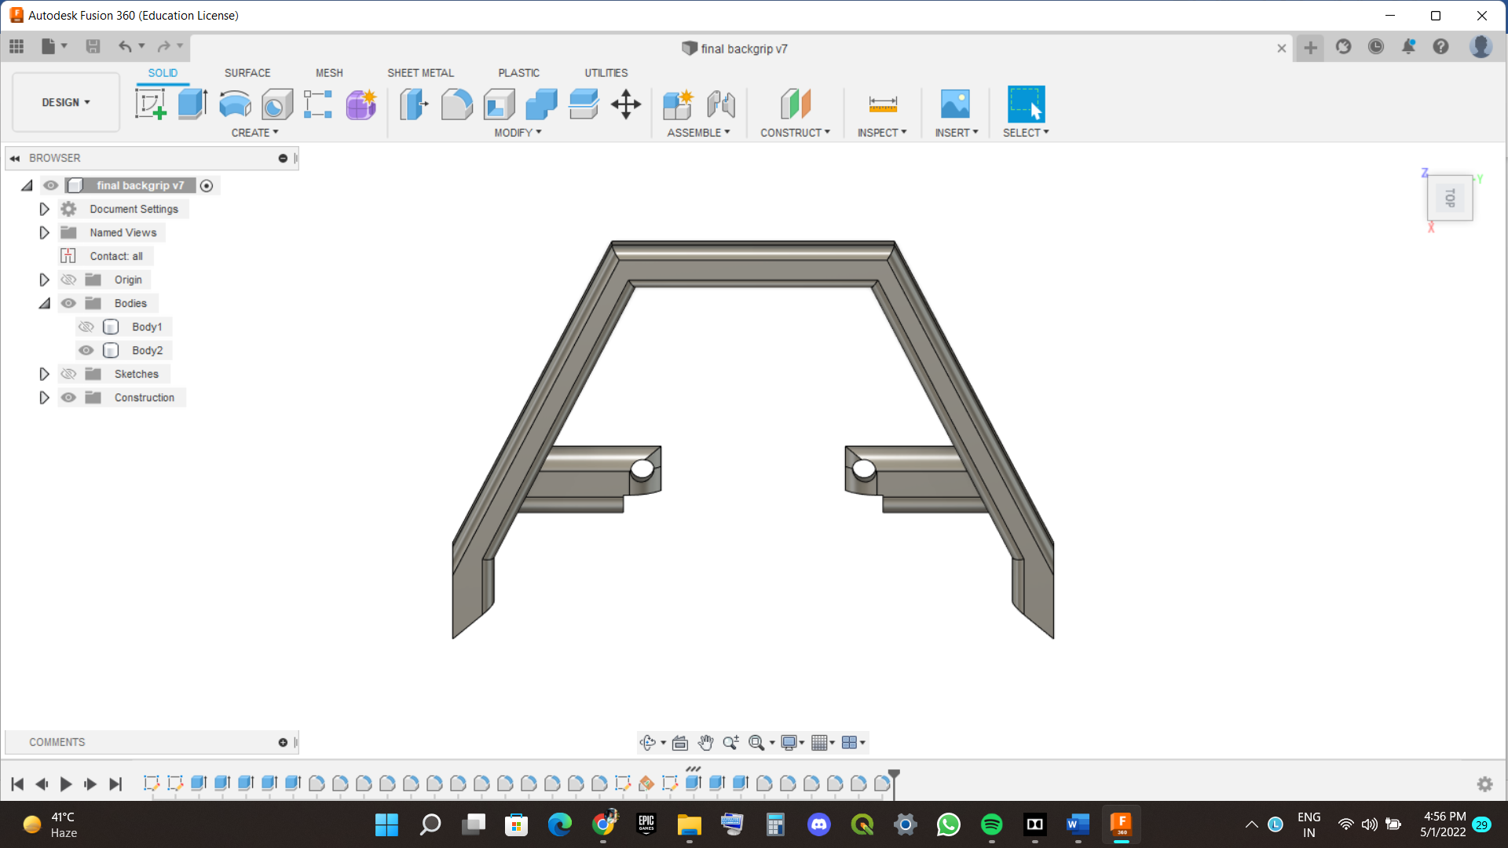

This the back grip without angle.

Home View

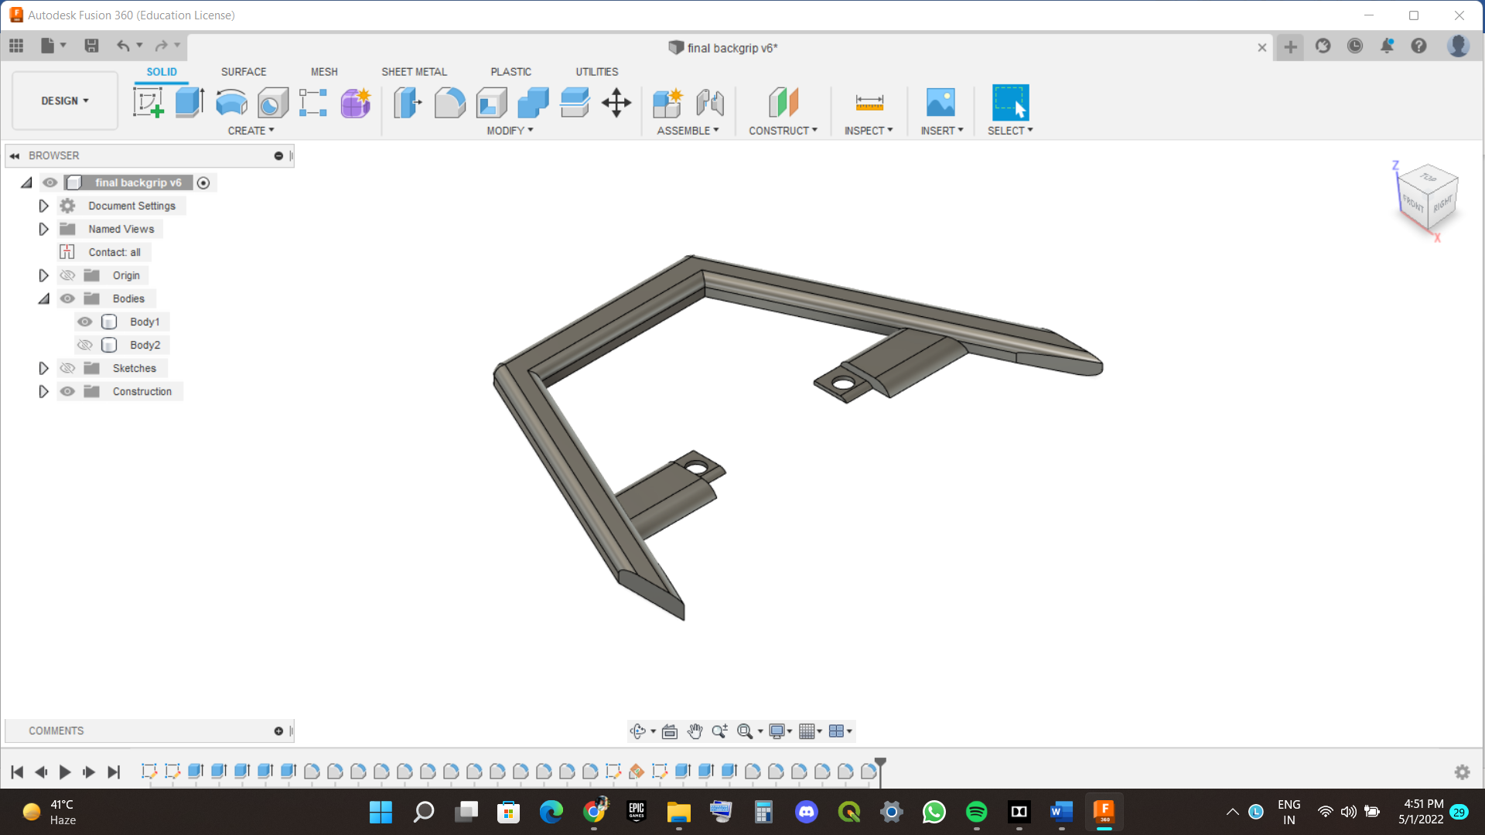 Top View

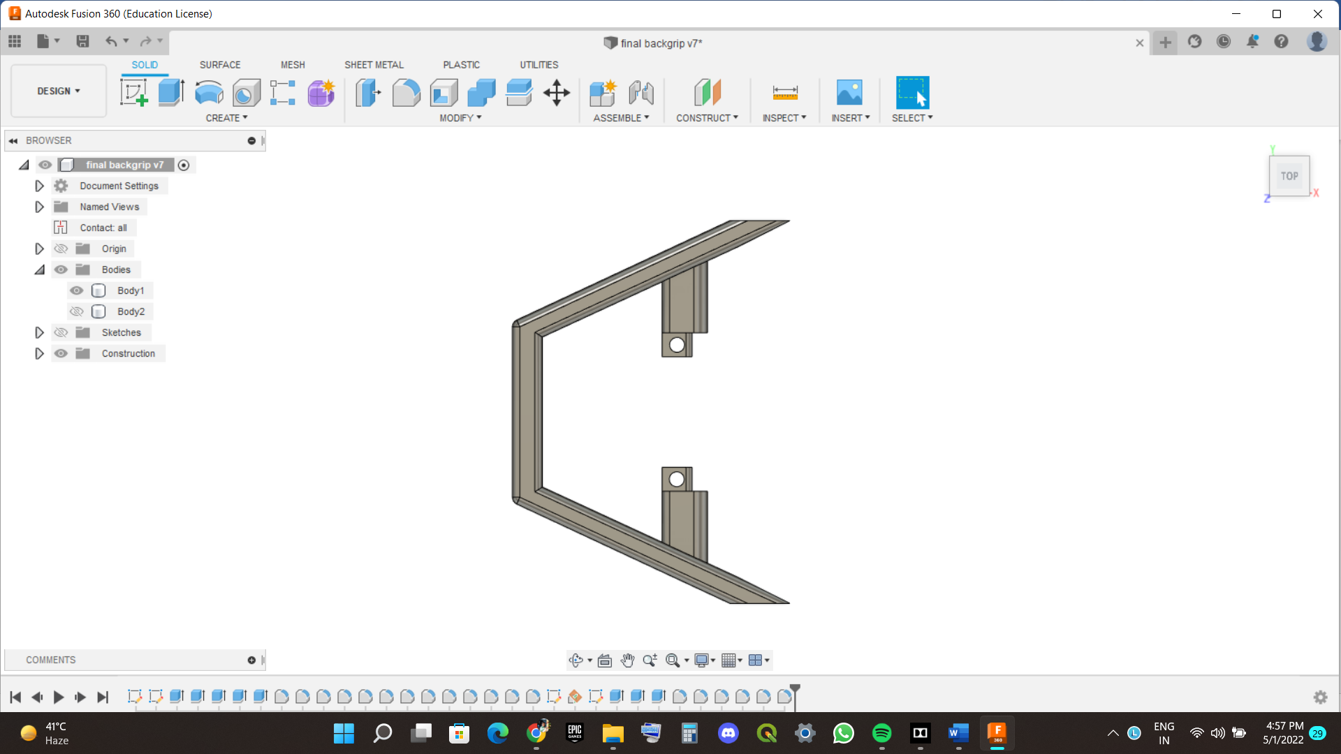

**2D SKETCH OF BACK GRIP**

The back grip with angle.

All dimensions are mentioned as per the measurements of the grip according to the fix position of it.

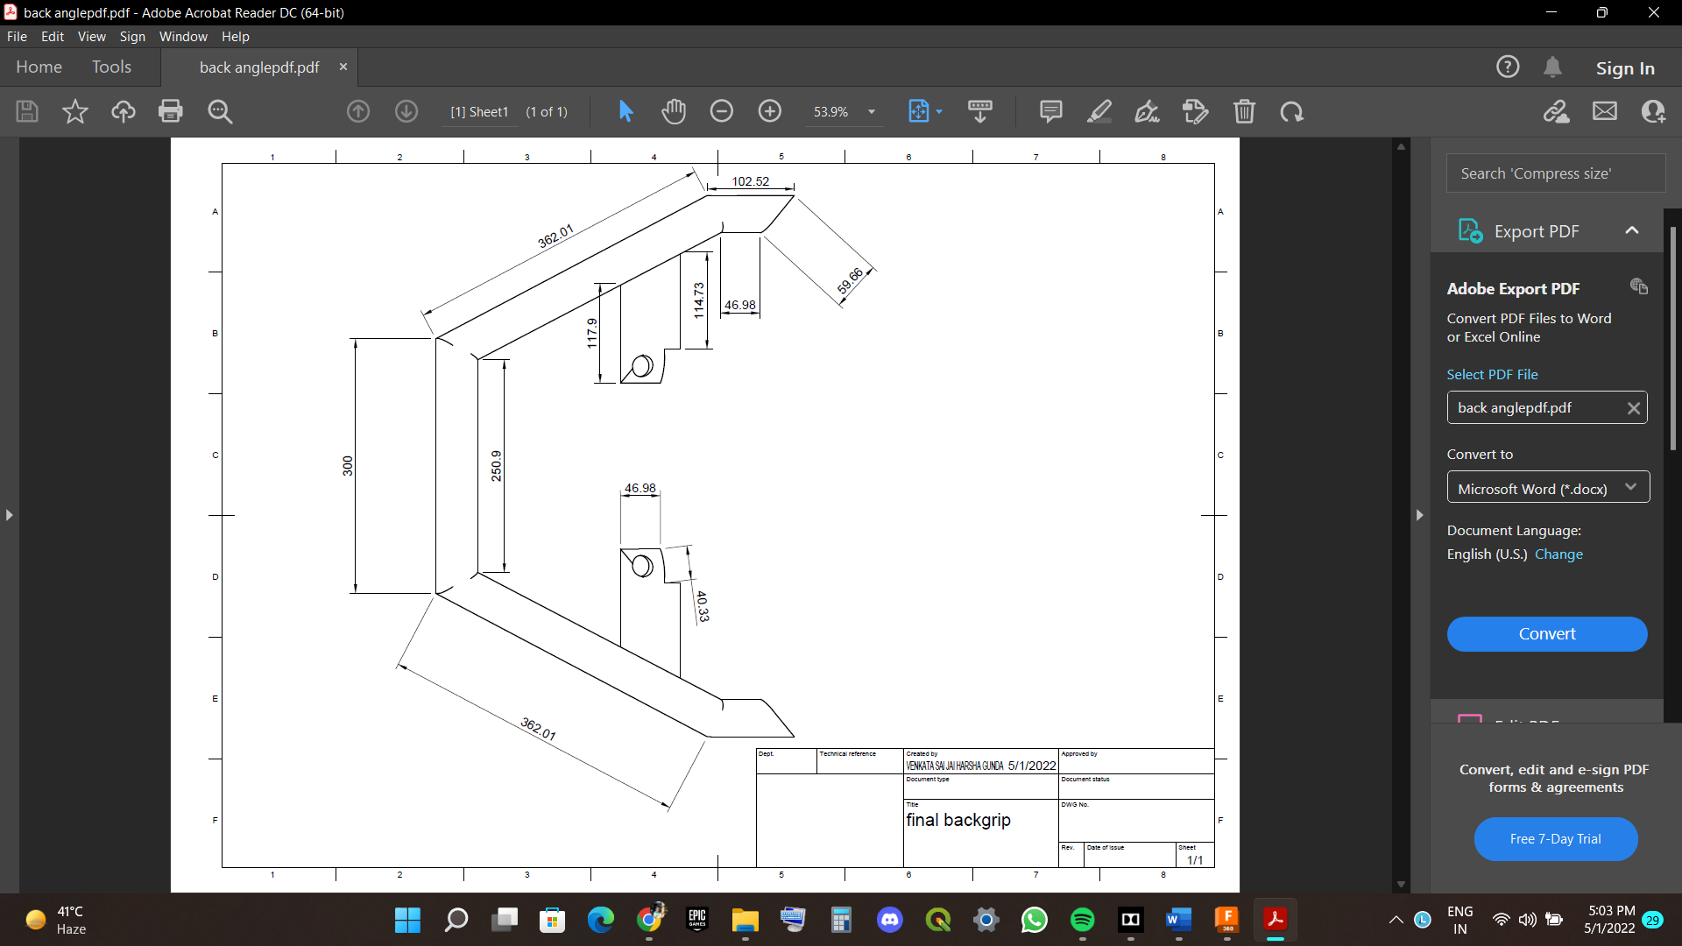

This the back grip without angle.

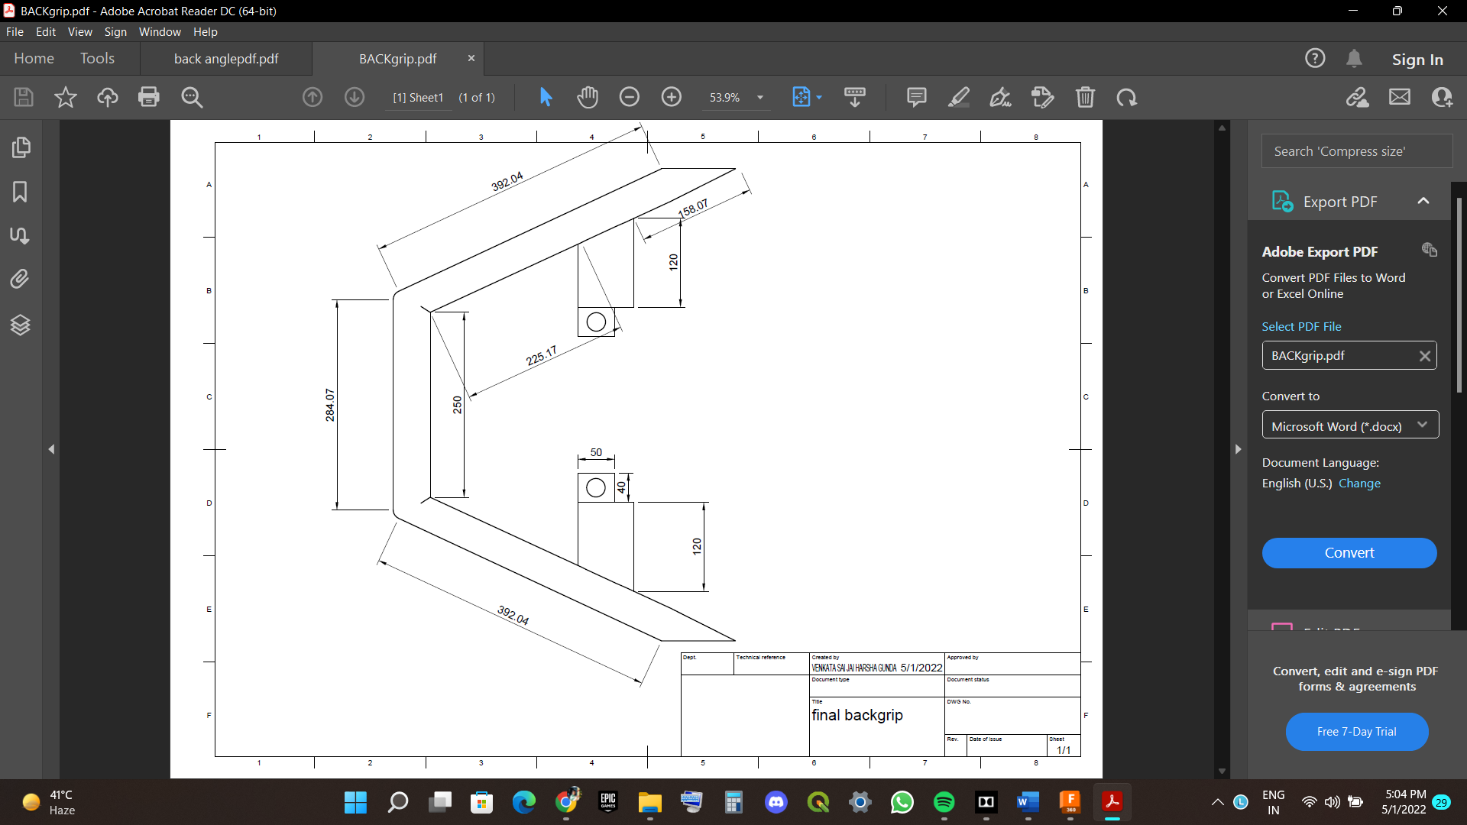

**FITMENT OF THE BACK GRIP.**

The fitment of the back grip is by bolt of size 12mm under neath the seat. The back grip has two holes of size 12mm we will be fixing it by bolt by T shaped spanner with tight and the cover the seat dome and last seat will be covered, and we will be checking it is perfectly fit or not.

These are photos which, I have fitted the back grip of Hero Destini as like this we will fitting the Hero Mastero Edge.

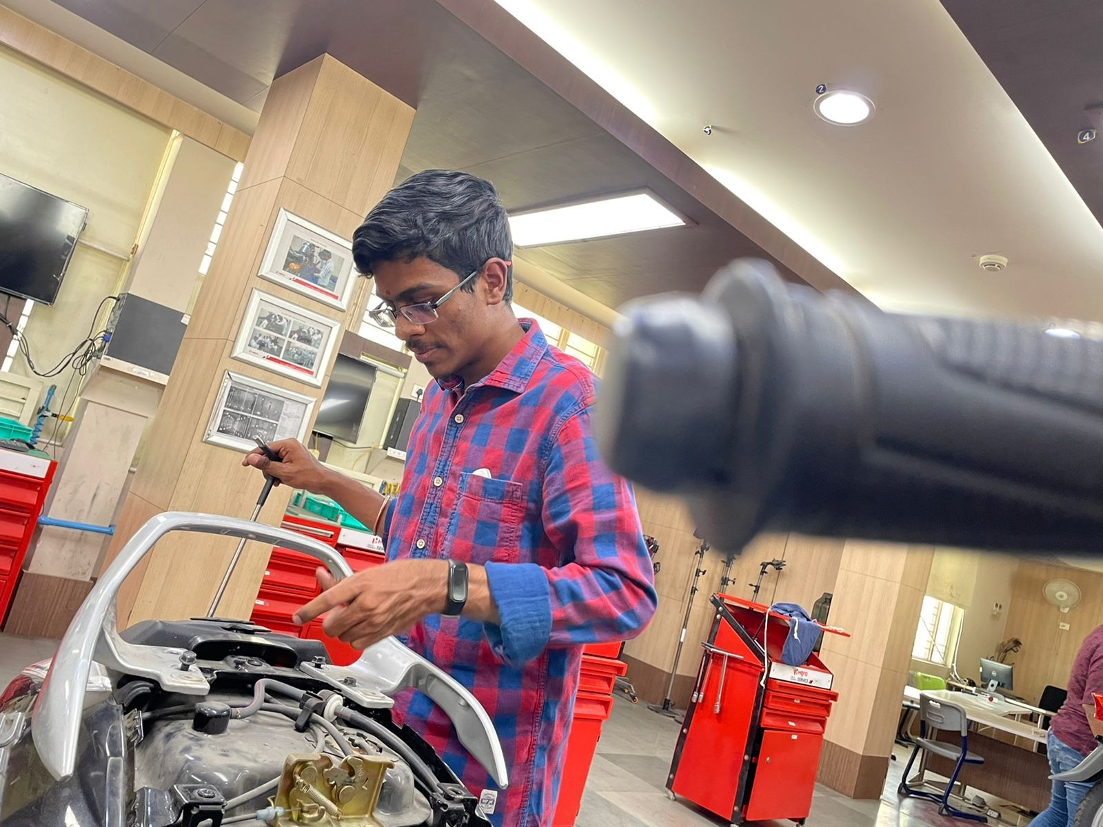

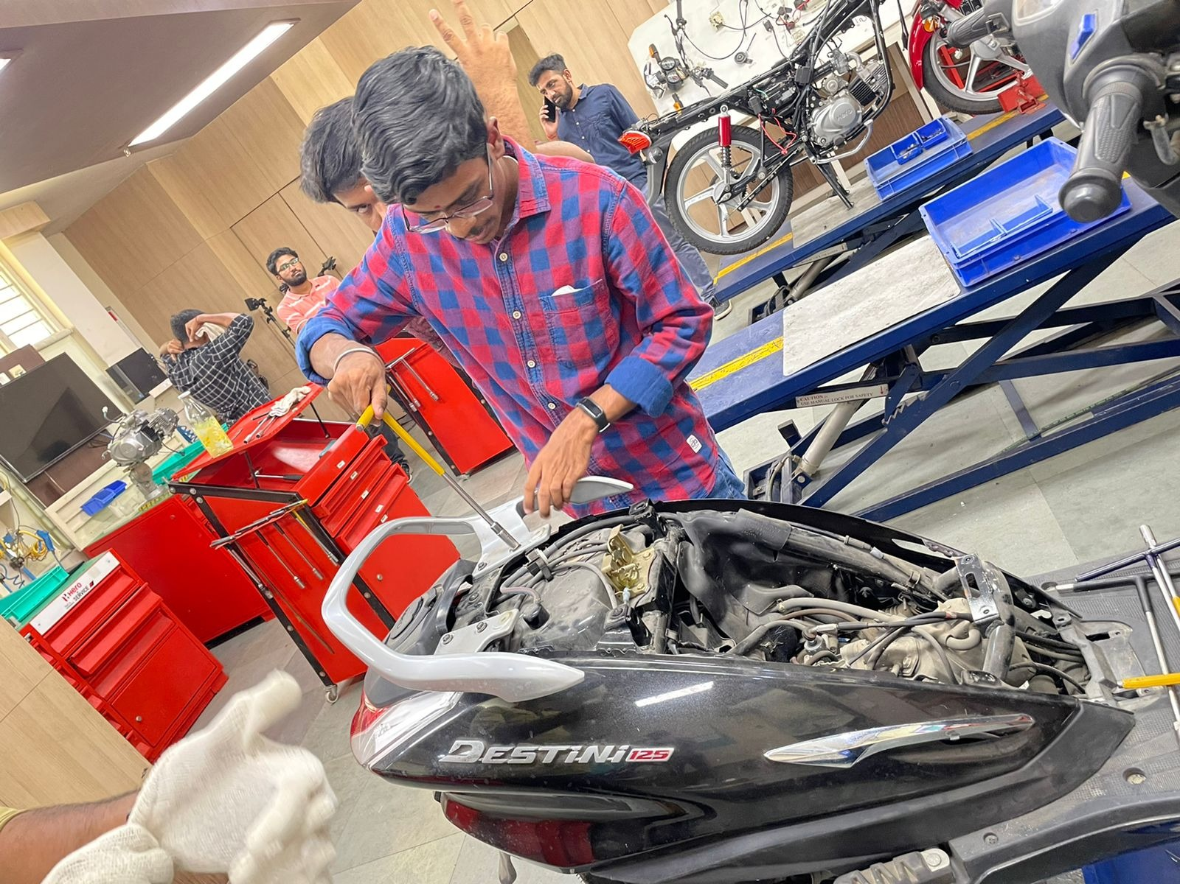

After fitting the bolts, we have cover with the Seat dome and fix it.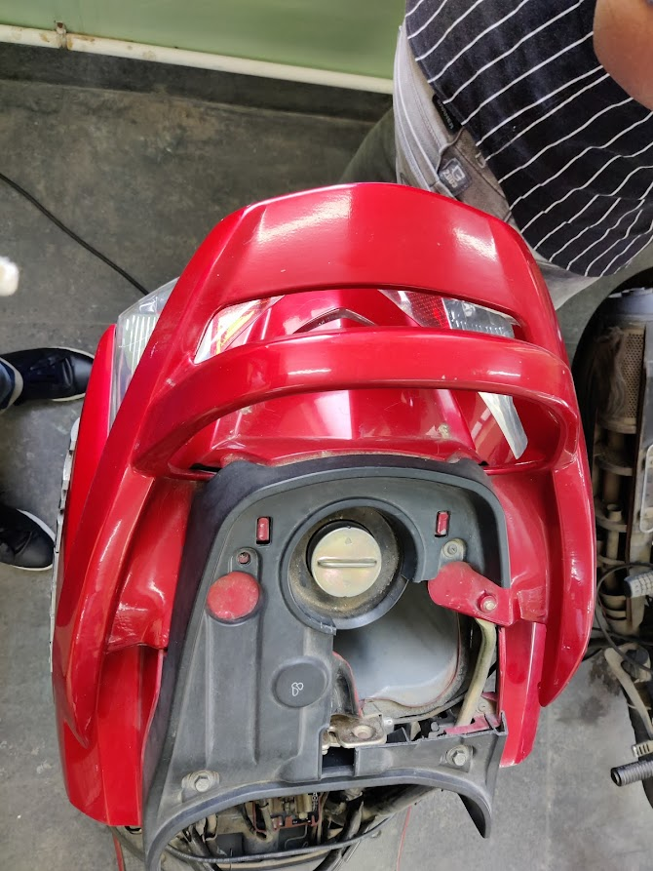

At last, it will be covered with the seat. It is fitted perfectly.

**GAP ANALYSIS OF THE BACK GRIP.**

In this we will be studying the gaps which are there between grip-seat ,grip-side cover, grip-back cover etc all will disused here.

First, we will be seeing the Grip-seat and sides.

2d sketch of the seat to check the gaps between seat and grip back and the sides.

Top view

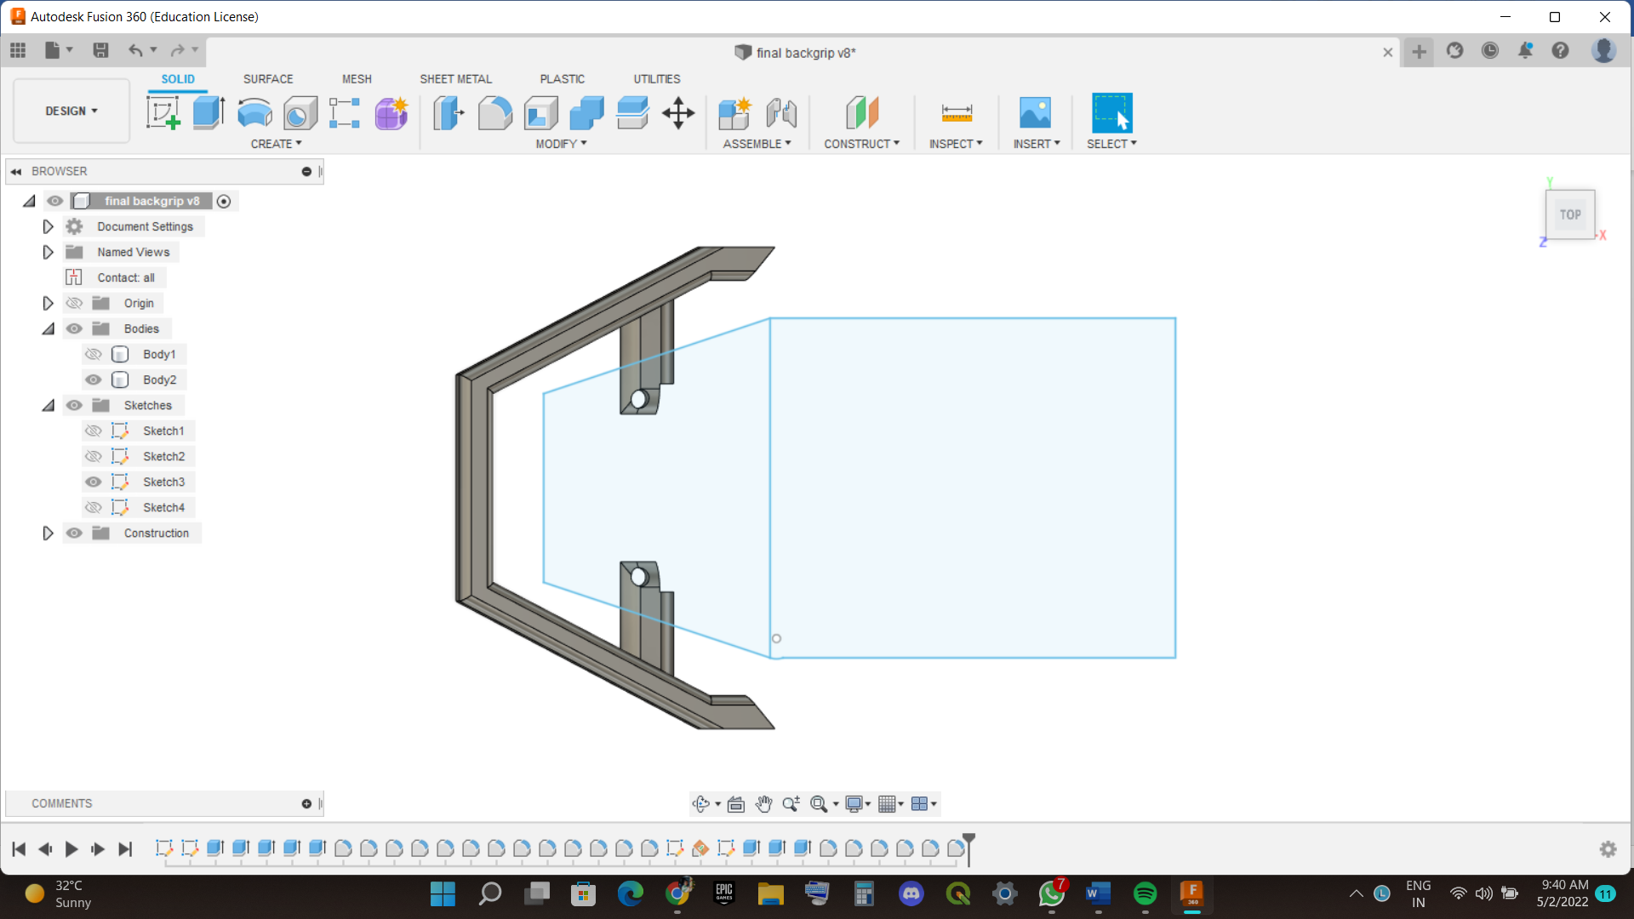

The gap between the seat and the grip back side is 7cm and satisfy to keep hands at backside.

The gap Between the seat and the grip side is 3.7cm it satisfy to keep the hands at side.

we will be seeing the Grip-seat height from back cover.

Home view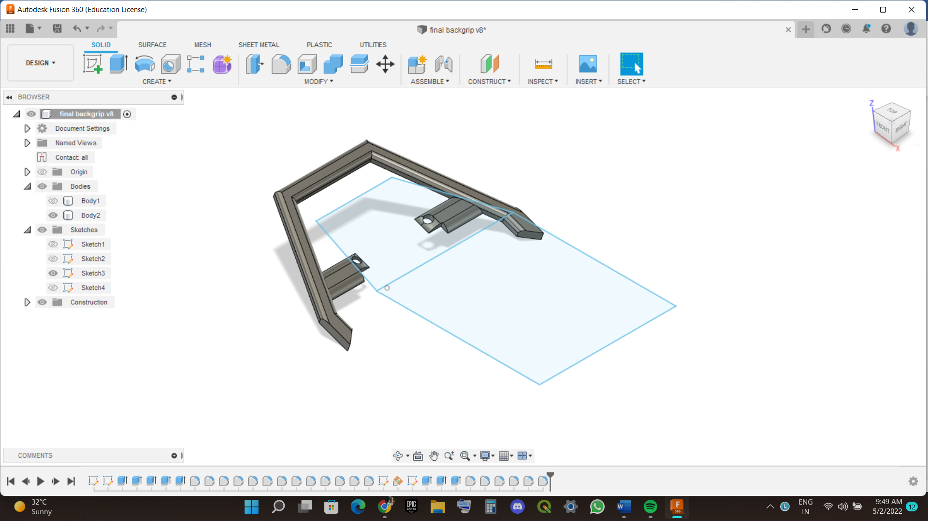

The gap between the seat and the grip back side height is 6cm and satisfy to keep hands at backside.

These gaps satisfy the pillion passenger to keep their hand at back side or side and with proper safety gaps.

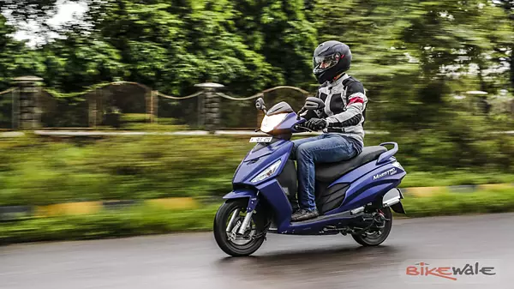

**CLASHING OF PARTS WITH BACK GRIP.**

The Seat and seat dome Cover are the clashing with the back grip.

As I have explained in fitment and gaps of the back grip if these are satisfied, we will not get any problem with the clashing because it will perfectly back grip is fitted.

In this we can see seat with hollow structure so we can see the clashing the grip.

Home View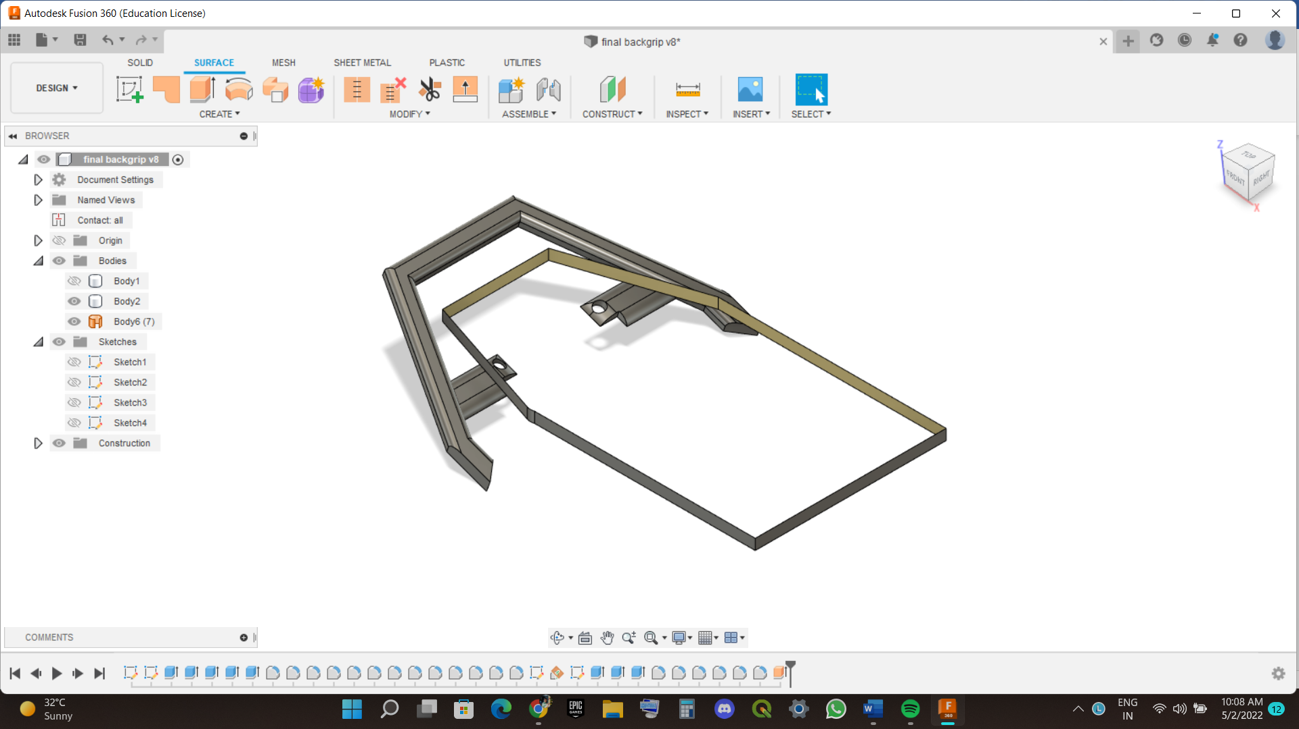

Top view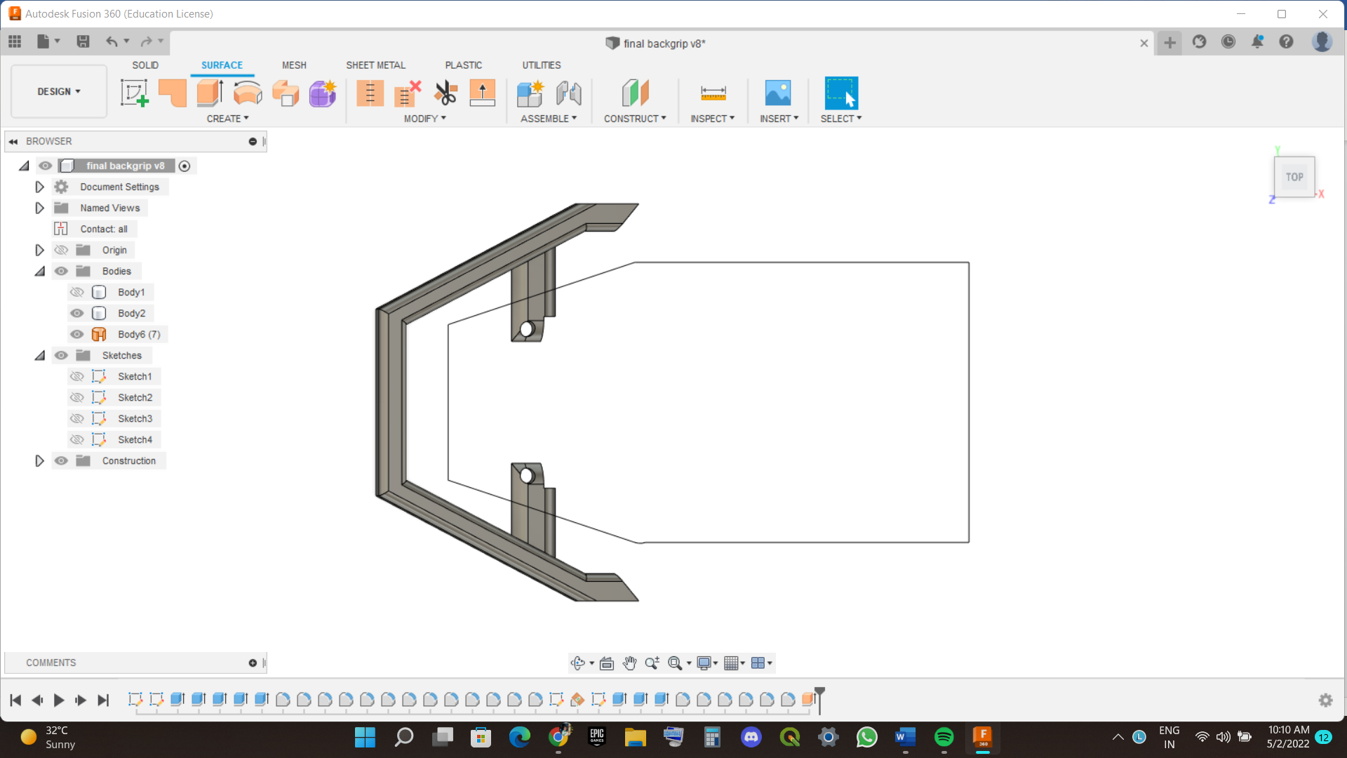

**FUNCTION ANALYSIS OF THE BACK GRIP.**

The function analysis of the back grip is to hold the hands of pillion rider and support the person to sit at back side without falling.

The person and hold the back grip back side with proper gap with big and short hands depend on the person it satisfy all types of persons.

The person can hold side of the grip and there is proper gap for it also and satisfy all types of persons.

It protects the pillion rider confidence not to fall down from the vehicle when we accelerate the vehicle.

It is safety feature of the pillion rider for riding and keep their hand on grip for support.

**Conclusion**

In this project I have learned about the modelling of the body part of bike and designing and modelling of the part make the project more interesting and we have validated the things like fitment , gap . clashing report these make me learn more about the body part design and thank you sir for providing these type of projects makes more experiential learning and make us more Enthusiastic and Thank you for Supporting staff for providing the dimensions of the part.

THANK YOU SIR